PF Lab Assignment

# **Problem 1:**

### **Source code:**

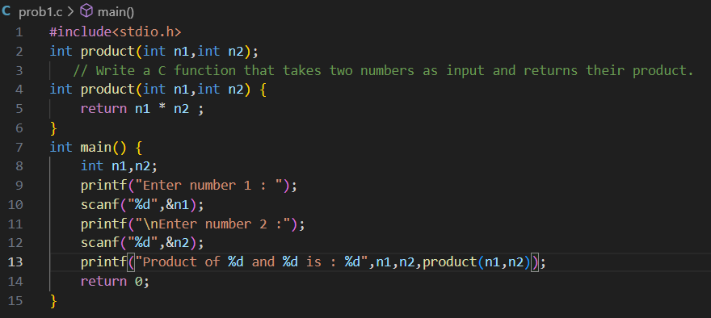

### **Output:**

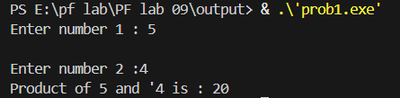

# **Problem 2:**

### **Source code:**

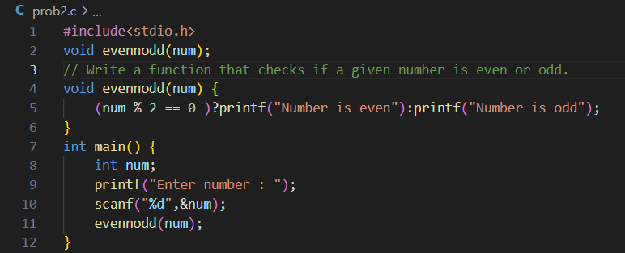

### **Output:**

# **Problem 3:**

### **Source code:**

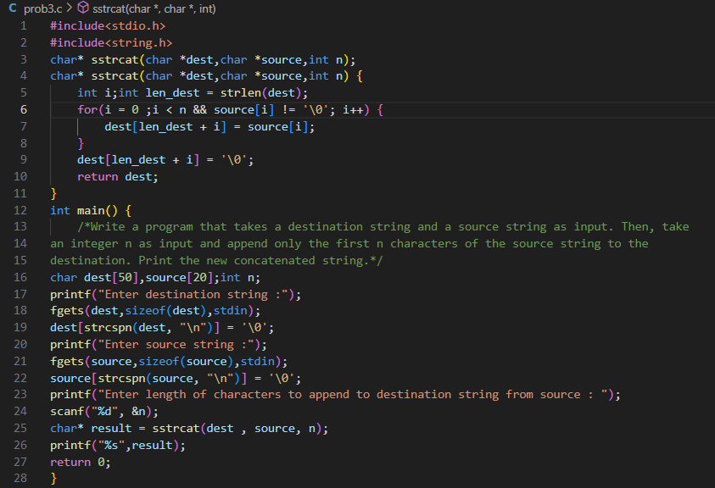

### **Output:**

# 

# **Problem 4:**

### **Source code:**

### 

### **Output:**

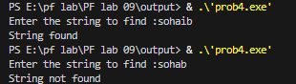

# **Problem 5:**

### **Source code:**

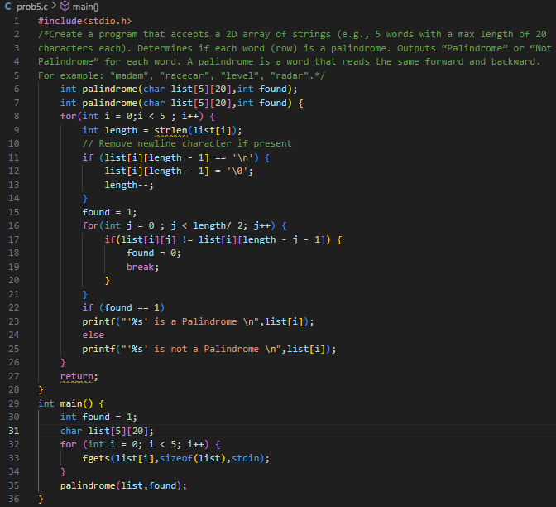

### **Output:**

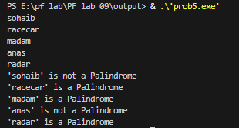

# **Problem 6:**

### **Source code:**

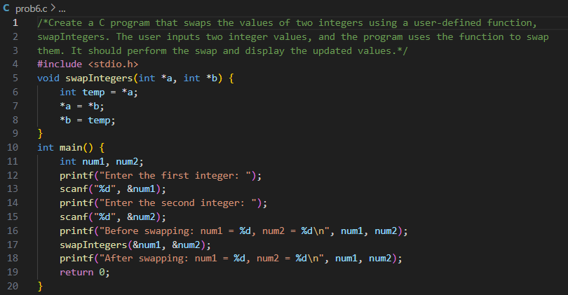

### **Output:**

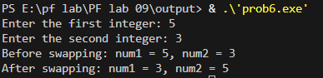

# **Problem 7:**

### **Source code:**

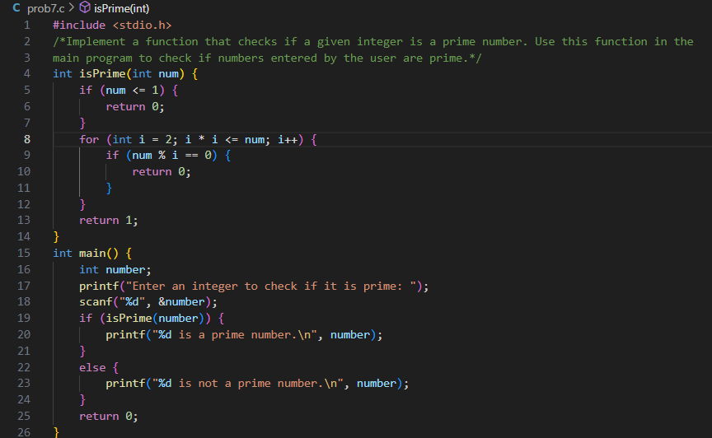

### **Output:**

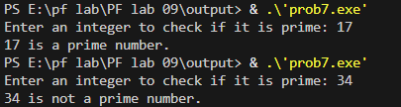

# **Problem 8:**

### **Source code:**

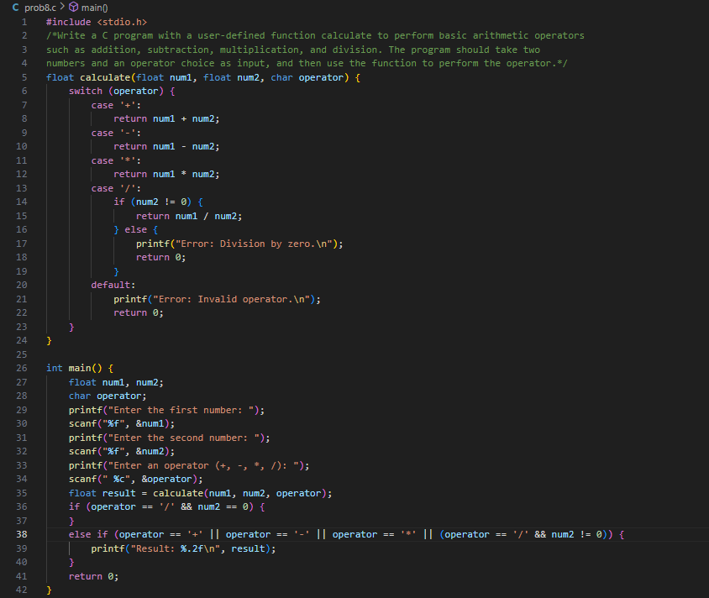

### **Output:**

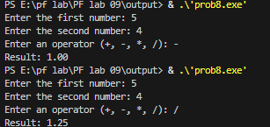

# **Problem 9:**

### **Source code:**

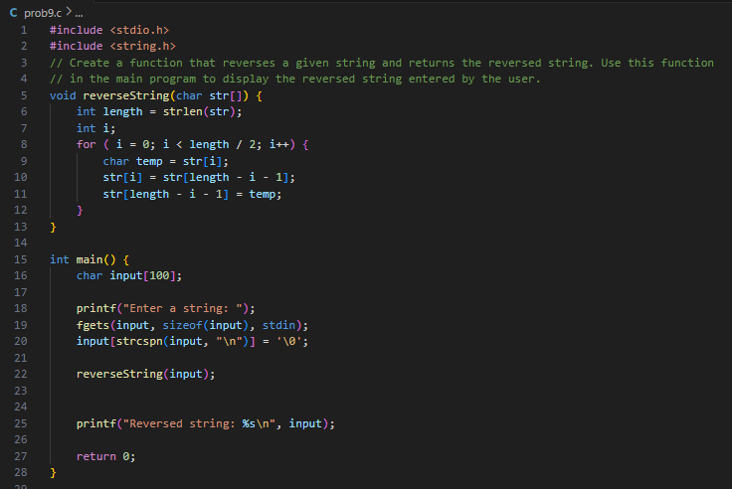

### **Output:**



# **Problem 10:**

### **Source code:**

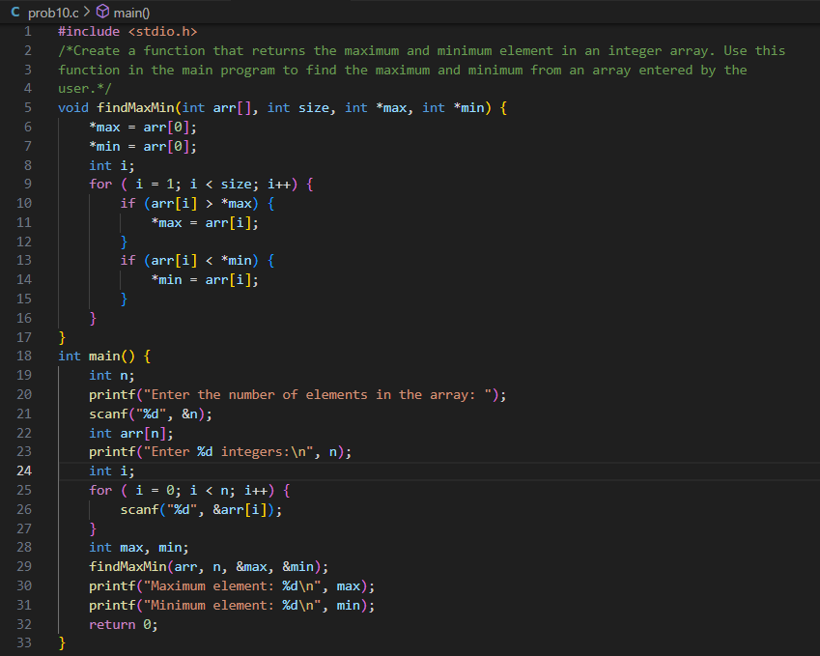

### **Output:**

### 